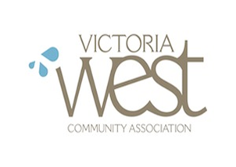VWCA Committee of the Whole September 25, 2018
6:00 P.M. at the Victoria West Community Centre
In Attendance: Justine Semmens, Susan Morrow, Mike Medland, Sean Dance, Laura Floyd
- Call to Order – By Justine Semmens at 6:10PM
- Adoption of agenda
- Susan Morrow: Summary of Board Evaluation
Feedback
-fill in responses at the meeting
-Is there a better evaluation scale (maybe/unsure option potentially confusing)?
- What’s Johannes job, how much communication with Johanne, who’s the point person.
- Formal on-boarding document.
- Checking in: priorities for September 2018 to the end of January 2019
HR: Website, privacy, workplace bullying
Land use: Johnson Street bridge (more concrete than desired), 805 Mary street 4 town houses.
Finance: Need more bodies,
President: Move AGM permanently,
Governance: Update policy manual (right dates), record keeping, collaboration with outside organizations, bylaw status, volunteer code of conduct implementation.
Board:
- All committees should review and update committee terms of reference – governance committee will take lead on ensuring all committee have one
- develop fresh policy defining how VWCA interacts with the community projects that fall under its scope – (largest food security – might meld into project and events)
- Comprehensive needs assessment (Justine/Dar); develop clear advocacy policy (Exec/Gov)
- Prepare a report on the needs VWCA intends to serve for presentation at AGM.
Committees:
Executive: shifting AGM permanently to the end of January of each calendar year; develop a robust recruitment strategy for officers of the VWCA
Governance: completing the update of the existing VWCA policy manual; drafting new policy/guidelines for the board on advocacy and collaboration with external community groups; We have also highlighted the need to review the VWCA processes for record-keeping
Finance
Human Resources:
Harbours:
Transportation/Parks:
Land Use:
Projects and Events:

- Board recruitment and engagement: Committee speed dating, October 30 2018
- Speaker mural person.
- New items

